SMART RESTAURANT MANAGEMENT SYSYTEM

MINOR PROJECT REPORT

Submitted in partial fulfillment of the requirement for the Degree of Bachelors of Engineering in Computer Science & Engineering
Submitted To:



[PARUL UNIVERSITY, VADODARA, GUJARAT (INDIA)]

Submitted By:
YASH RAJ(2303051051261) RITIK Kumar (2303051051148)

RISHAV THAKUR(2303051051071) VISHAL SINGH(2303051051165)

Under The Guidance of:

MR. AMIT GUPTA
(Faculty, Department of Computer Science & Engineering)

DEPARTMENT OF COMPUTER SCIENCE & ENGINEERING PARUL INSTITUTE OF TECHNOLOGY VADODARA, GUJARAT SESSION: AY 2025-2026

Parul University
Parul Institute of Technology
(Session: 2025 -2026)

DEPARTMENT OF COMPUTER SCIENCE & ENGINEERING

CERTIFICATE

This is to certify that Yash Raj, Ritik Kumar, Rishav thakur, Vishal Singh, Students of CSE VI Semester of “ Parul Institute of Technology, Vadodara” has completed their Minor Project titled “SMART RESTAURANT MANAGEMENT SYSTEM ”, as per the syllabus and has submitted a satisfactory report on this project as a partial fulfillment towards the award of degree of Bachelor of Technology in Computer Science and Engineering under Parul University, Vadodara, Gujarat (India).

GUIDE NAME Prof. Sumitra Menaria DR. Swapnil Parikh
Amit Gupta Head (CSE) Principal
Assistant Professor PIT, Vadodara PIT, Vadodara (CSE / IT)

DECLARATION

We the undersigned solemnly declare that the project report “SMART RESTAURANT MANAGEMENT SYSTEM” is based on my own work carried out during the course of our study under the supervision of MR. AMIT GUPTA, Faculty, Department of Computer Science & Engineering

We assert the statements made and conclusions drawn are the outcomes of my own work. I further certify that
- The work contained in the report is original and has been done by us under the general supervision of our supervisor.
- The work has not been submitted to any other Institution for any other degree / diploma / certificate in this university or any other University of India or abroad.
- We have followed the guidelines provided by the university in writing the report.

Whenever we have used materials (data, theoretical analysis, and text) from other sources, we have given due credit to them in the text of the report and giving their details in the references.

NAME OF GROUP MEMBER1 [ENROLLMENT NO.] _____ SIGNATURE _____

NAME OF GROUP MEMBER2 [ENROLLMENT NO.] _____ SIGNATURE _____

NAME OF GROUP MEMBER3 [ENROLLMENT NO.] _____ SIGNATURE _____

ACKNOWLEDGEMENT

In this semester, we have completed our project on “Smart Restaurant Management System”. During this time, all the group members collaboratively worked on the project and learnt about the industry standards that how projects are being developed in IT Companies. We also understood the importance of teamwork while creating a project and got to learn the new technologies on which we are going to work in near future.

We gratefully acknowledge for the assistance, cooperation guidance and clarification provided by “Mr. AMIT GUPTA” during the development of our project. We would also like to thank our Head of Department Prof. Sumitra Menaria and our Principal Dr. Swapnil Parikh Sir for giving us an opportunity to develop this project. Their continuous motivation and guidance helped us overcome the different obstacles for completing the Project.

We perceive this as an opportunity and a big milestone in our career development. We will strive to use gained skills and knowledge in our best possible way and we will work to improve them.

NAME OF GROUP MEMBER1 [ENROLLMENT NO.] _____ SIGNATURE _____

NAME OF GROUP MEMBER2 [ENROLLMENT NO.] _____ SIGNATURE _____

NAME OF GROUP MEMBER3 [ENROLLMENT NO.] _____ SIGNATURE _____

LIST OF ABBREVIATIONS

HTML – HyperText Markup Language CSS – Cascading Style Sheets
JS – JavaScript

UI – User Interface

DFD – Data Flow Diagram ER – Entity Relationship DB – Database



ABSTRACT

A “Smart Restaurant Management System” is an integrated software solution designed to streamline and automate the various operations of a restaurant, improving efficiency, accuracy, and overall customer satisfaction. It typically includes features such as order management, table reservations, billing, inventory control, staff management, and customer relationship management, all within a single platform. By digitizing these processes, the system reduces manual errors, speeds up service, and provides real-time data that helps restaurant owners make informed decisions. For example, it can track sales trends, monitor stock levels to prevent shortages or wastage, and generate detailed reports on daily performance. Additionally, modern systems often support online ordering and payment integration, enhancing convenience for customers and expanding business reach. In a competitive food service industry, a well-implemented restaurant management system not only optimizes internal operations but also improves customer experience through faster service, accurate orders, and personalized interactions, ultimately contributing to increased profitability and sustainable growth.

- TABLE OF CONTENTS

- FIRST PAGE (Same as Cover Page)…...
- CERTIFICATE…………………………. | - II
- DECLARATION……………………….. | - III
- ACKNOWLEDGEMENT……………… | - IV
- LIST OF FIGURES…………………….. | - V
- LIST OF TABLES……………………... | - VI
- LIST OF ABBREVIATIONS…………. | - VII
- ABSTRACT……………………………. | - VIII
- INDEX (with Page No.)………………... | - IX

CHAPTER | TOPIC | PAGE NO.
Chapter I | INTRODUCTION | (Min. 3-4 Pages)
1.1 | O Overview
1.2 | Pr Problem Statement
1.3 | O Objective of Project
1.4 | A Applications or Scope
1.5 | Or Organization of Report
Chapter II | LI LITERATURE SURVEY | (Min. 3 Pages)
Chapter III | M METHODOLOGY | (Min. 5 Pages)
3.1 | Ba Background / Overview of Methodology
3.2 | Pr Object Platforms used in Project
3.3 | Pr Proposed Methodology
3.4 | Pr Object Modules
3.5 | D Diagrams (ER, Use Case DFD, etc.)
Chapter IV | SYSTEM REQUIREMENTS
4.1 | So Software Requirements
4.2 | Ha Hardware Requirements

Chapter V | EXPECTED OUTCOMES(with GUI) | (MIN 3 Pages)
Chapter VI | C CONCLUSION & FUTURE SCOPE | (Max. 2 Pages)
6.1 | C Conclusion
6.2 | Fu Future Work
Chapter VII | R REFERENCES | (At least 10)
Chapter VII | Weekly Report (Xerox / Original)

..

CHAPTER 1
INTRODUCTION

  - OVERVIEW
    - The overview of a Restaurant Management System (RMS) refers to a general introduction to how the system works and what it aims to achieve. It is a software-based solution designed to manage and automate the daily operations of a restaurant in an efficient and organized manner. The system integrates different functions such as order processing, billing, table management, inventory tracking, and staff coordination into one centralized platform. Its main goal is to reduce manual work, minimize errors, and improve the speed and quality of service. By providing real-time data and reports, it helps restaurant owners monitor performance, manage resources effectively, and make better business decisions. Overall, the overview highlights that a restaurant management system is an essential tool for modern restaurants to enhance productivity, ensure smooth operations, and deliver a better customer experience.

Key Objectives
- Order Management System – Allows staff to take and process orders digitally through tablets or POS systems, reducing errors and improving speed. It can also support online and mobile orders.

- Table Reservation & Management – Enables customers to book tables in advance and helps staff manage table availability, seating arrangements, and waitlists efficiently.

- Billing & Payment Integration – Generates accurate bills automatically and supports multiple payment methods such as cash, cards, UPI, and digital wallets for faster checkout.

- Inventory Management – Tracks stock levels in real-time, alerts when items are low, and helps prevent wastage by managing raw materials effectively.

- Menu Management – Allows easy updating of menu items, prices, and availability. Smart systems can also highlight popular or recommended dishes.

- Customer Relationship Management (CRM) – Stores customer data, order history, and preferences to provide personalized services, offers, and loyalty programs.

- Staff Management – Helps manage employee schedules, attendance, roles, and performance, improving workforce productivity.

- Real-time Analytics & Reporting – Provides detailed insights into sales, revenue, customer behavior, and inventory usage to support better decision-making.

  - PROBLEM STATEMENT

  - The problem statement of a Smart Restaurant Management System focuses on the challenges faced by traditional restaurant operations and the need for an efficient solution:
  - In many restaurants, daily operations such as order taking, billing, inventory tracking, and staff coordination are managed manually or through disconnected systems, leading to inefficiencies and errors. Manual order processing often results in incorrect orders, delays in service, and poor communication between staff and the kitchen. Inventory is difficult to track accurately, causing overstocking or shortages, which increases costs and reduces profitability. Billing errors and slow payment processes can negatively affect customer satisfaction. Additionally, restaurant owners lack real-time insights into sales, customer preferences, and overall performance, making it difficult to make informed decisions. Managing reservations, staff schedules, and multiple branches further adds to the complexity. Therefore, there is a need for a smart, integrated restaurant management system that automates operations, improves accuracy, enhances customer experience, and provides real- time data for better decision-making and efficient business management.

  - OBJECTIVE OF PROJECT

  - The objectives of a Smart Restaurant Management System are to improve the efficiency, accuracy, and overall performance of restaurant operations through automation and integration. The primary objective is to streamline daily activities such as order taking, billing, and table management, reducing manual effort and minimizing errors. Another key objective is to enhance customer satisfaction by providing faster service, accurate orders, and convenient payment options. The system also aims to manage inventory effectively by tracking stock levels in real time and reducing wastage. Additionally, it seeks to improve decision-making by generating detailed reports and analytics on sales, customer preferences, and business performance. Managing staff efficiently, including scheduling and performance monitoring, is another important goal. Furthermore, the system aims to support online ordering and reservations, expanding the restaurant’s reach and accessibility. Overall, the objective is to create a smart, centralized platform that optimizes operations, increases profitability, and delivers a seamless dining experience.

  - SCOPE OF PROJECT

  - The scope of the Smart Restaurant Management System defines the boundaries and functionalities covered by the project, highlighting how it will be used to improve restaurant operations. The system is designed to manage core activities such as order processing, billing, table reservations, and inventory management within a single integrated platform. It covers both front-end operations, like customer ordering, digital menus, and payment processing, and back-end operations, such as stock tracking, report generation, and staff management. The project also includes features like real-time data monitoring, customer information management, and analytics to support better decision-making. Additionally, it can be extended to support online ordering, home delivery integration, and multi-branch management for larger restaurant chains. However, the scope may be limited to software implementation and may not include hardware components like POS devices or kitchen equipment. Overall, the project focuses on creating an efficient, user-friendly system that automates restaurant workflows, improves service quality, and enhances business productivity.

    - Platform Development: Design and implement a web-based platform that allows users to access information easily.

    - User Registration and Authentication: Provide secure login and registration functionality for users and administrators.

    - Tournament Management: Allow administrators to create, edit, and manage tournaments, including schedules and participating teams.

    - Team Management: Enable teams to register, manage their profiles, and participate in tournaments.

    - News and Announcements: Offer a section where administrators can publish e- sports related news and updates.

    - Data Storage and Management: Utilize cloud-based databases to store tournament details, team profiles, match results, and news articles securely.

    - User Information Access: Allow users to browse tournaments, teams, and match results without complexity.

  - ORGANIZATION OF REPORT
The report is organized into several chapters to provide a structured explanation of the project development process and system design.
Introduction

This chapter provides an overview of the project, including the problem statement, objectives, and scope of the proposed system.
Literature Review

This chapter explains the overall methodology used in the project, including system architecture, design approach, and development techniques.
Project Implementation

This section describes the modules and functionalities of the platform, along with the tools and technologies used during development.
Results and Findings

This chapter presents the outcomes of the developed system, including the user interface, functionality, and system performance.

Discussion
This section analyzes the strengths and limitations of the system and discusses the challenges encountered during development.

Conclusion
This chapter summarizes the overall project work and highlights the achievements of the system. The Smart Restaurant Management System provides an efficient and modern solution to the challenges faced in traditional restaurant operations. By integrating various functions such as order management, billing, inventory control, and customer handling into a single platform, it significantly reduces manual effort and minimizes errors. The system enhances service speed and accuracy, leading to improved customer satisfaction and better overall dining experiences.

References
This section lists all books, research papers, articles, and online resources used during the development of the project.

CHAPTER 2
LITERATURE SURVEY

  - The restaurant industry has undergone significant transformation with the adoption of digital technologies. Traditional restaurant operations relied heavily on manual processes such as handwritten order-taking, paper-based reservations, and manual billing systems. These approaches often resulted in inefficiencies, errors, and delays in service. To overcome these challenges, various researchers have proposed automated Restaurant Management Systems (RMS) to streamline operations and enhance customer satisfaction.
  - Several studies highlight that early RMS solutions primarily focused on basic functionalities such as order management, billing, and customer record maintenance. For instance, an online restaurant management system was introduced to reduce manual workload and improve accuracy by maintaining digital records of customers, orders, and staff activities. These systems also enabled easy food ordering through user-friendly interfaces and automated billing processes.

Importance of this Platforms
  - Machine learning models are increasingly used to analyze customer reviews and feedback to understand customer preferences and improve service quality. This helps restaurant owners make data-driven decisions to enhance customer satisfaction and loyalty .

Key Advantages of this Platforms

Improved Efficiency
  - An RMS automates daily operations such as order taking, billing, and inventory management, reducing manual work and saving time.

Faster Order Processing
  - Orders are directly sent to the kitchen through the system, minimizing delays and improving service speed.

Accuracy and Error Reduction
  - Digital systems reduce human errors in order-taking, billing, and calculations, ensuring accurate transactions.

Better Inventory Management
  - Tracks stock levels in real-time, prevents overstocking or shortages, and helps in efficient resource utilization.

Challenges and Considerations

High Initial Cost
  - Implementing an RMS requires investment in hardware, software, and setup, which can be expensive for small restaurants.

Technical Issues
  - System crashes, bugs, or server downtime can disrupt operations and delay service.

Training Requirements
  - Staff need proper training to use the system effectively, which takes time and effort.

Data Security Risks
  - Customer data and payment information can be vulnerable to cyberattacks if proper security measures are not implemented.

Internet Dependency
  - Many modern RMS solutions depend on internet connectivity; poor network can affect performance.

Resistance to Change
  - Employees may be reluctant to switch from traditional methods to digital systems.

Maintenance and Updates
  - Regular updates and maintenance are required to keep the system running smoothly.

Integration Issues
  - Difficulty in integrating RMS with other systems like payment gateways, delivery apps, or accounting software.

System Complexity
  - Some systems may be complex and difficult to use, especially for non-technical staff.

Data Loss Risk
  - If backups are not maintained, system failures can lead to loss of important business data

Summary of Literature Survey
The literature survey highlights the evolution of restaurant management from traditional manual systems to modern automated solutions. Earlier systems relied on paper-based processes, which were time-consuming and prone to errors. To address these issues, researchers introduced digital Restaurant Management Systems that automate key operations such as order processing, billing, and inventory management.

With technological advancements, RMS has expanded to include web and mobile-based applications, enabling features like online ordering, table reservations, and real-time tracking. Recent studies emphasize the integration of advanced technologies such as QR code ordering, data analytics, and artificial intelligence to improve efficiency and customer satisfaction.

CHAPTER 3 METHODOLOGY

OVERVIEW OF METHODOLOGY
  - The methodology defines the step-by-step process used to design, develop, and implement the Restaurant Management System. It ensures that the system is efficient, reliable, and user-friendly.

Requirement Analysis
- Identify system requirements by analyzing restaurant operations.
- Understand user needs such as admin, staff, and customer functionalities.
- Define features like order management, billing, inventory, and reservations.

System Design
- Create system architecture and workflow diagrams.
- Design database structure (tables for customers, orders, menu, staff, etc.).
- Develop user interface designs for web/mobile applications.

Technology Selection
- Choose appropriate technologies such as:
  - Frontend: HTML, CSS, JavaScript
  - Backend: Node.js / Express
  - Database: MongoDB
- Ensure scalability and performance.

Development (Implementation)
- Build modules such as:
  - User authentication (login/signup)
  - Menu management
  - Order processing system
  - Billing and payment integration
- Follow modular programming approach.

Testing
- Perform testing to ensure system works correctly:
  - Unit Testing (individual modules)
  - Integration Testing (combined modules)
  - System Testing (overall functionality)
- Fix bugs and improve performance.

Deployment
- Deploy the system on a server or cloud platform.
- Make it accessible to users (restaurant staff and customers).

Maintenance
- Regular updates and improvements.
- Fix issues and add new features based on feedback.

Integrated Development Environment Features:
Despite being lightweight, VS Code provides debugging tools, Git integration, version control, and an integrated terminal, which helps streamline the development process.

Proposed Methodology of Restaurant Management System
The proposed methodology describes how the system will be designed and implemented to improve restaurant operations using modern technology.

System Approach
The system follows a web-based and/or mobile-based approach where customers and staff interact through a digital platform instead of manual processes.

Modular Design
The system is divided into different modules for better management:

Admin Module
  - Manage menu, staff, and reports

Customer Module
  - View menu, place orders, book tables

Kitchen Module
  - Receive and process orders

Billing Module
  - Generate bills and handle payments

Workflow of the System
- Customer logs into the system or scans QR code
- Views digital menu
- Places order through the system
- Order is sent directly to the kitchen
- Kitchen prepares the order
- Bill is generated automatically
- Customer makes payment (online/offline)

Technology Implementation
- Frontend: User-friendly interface (HTML, CSS, JavaScript)
- Backend: Server-side logic (Node.js / Express)
- Database: MongoDB for storing data
- Integration: Payment gateway, QR code system

Data Management
- Store customer details, orders, payments, and inventory
- Ensure data security and backup

Testing and Validation
- Test all modules for accuracy and performance
- Ensure system works in real-time without errors

Deployment Strategy
- Deploy on cloud/server
- Provide access to admin and users via web/mobile

Continuous Improvement
- Collect feedback from users
- Update system with new features and improvements

Conclusion of Proposed Methodology
- The proposed methodology focuses on automation, efficiency, and user convenience, reducing manual work and improving overall restaurant performance

1.1 PROJECT MODULES

Admin Module
- Manages the entire system
- Add, update, or delete menu items
- Manage staff details
- View reports and analytics
- Monitor orders and payments

Customer Module
- User registration and login
- View digital menu
- Place orders online
- Book tables/reservations
- View order history

Order Management Module
- Handles order placement and tracking
- Sends orders to the kitchen
- Updates order status (pending, preparing, completed)

Kitchen Module
- Displays incoming orders
- Helps kitchen staff prepare food efficiently
- Updates order status after preparation

Billing & Payment Module
- Generates automatic bills
- Supports multiple payment options (cash, card, UPI)
- Maintains transaction records

Inventory Management Module
- Tracks stock of ingredients
- Alerts for low stock
- Reduces wastage and overstocking

Staff Management Module
- Maintains employee records
- Tracks attendance and roles
- Assigns tasks

Reservation Module
- Allows table booking in advance
- Manages table availability
- Reduces waiting time

Reporting & Analytics Module
- Generates sales reports
- Tracks daily/monthly performance
- Helps in decision-making

Feedback Module
- Collects customer feedback and ratings
- Helps improve service quality

Conclusion
- These modules work together to create a complete Restaurant Management System, improving efficiency, accuracy, and customer satisfaction.

1.1 DIAGRAMS:

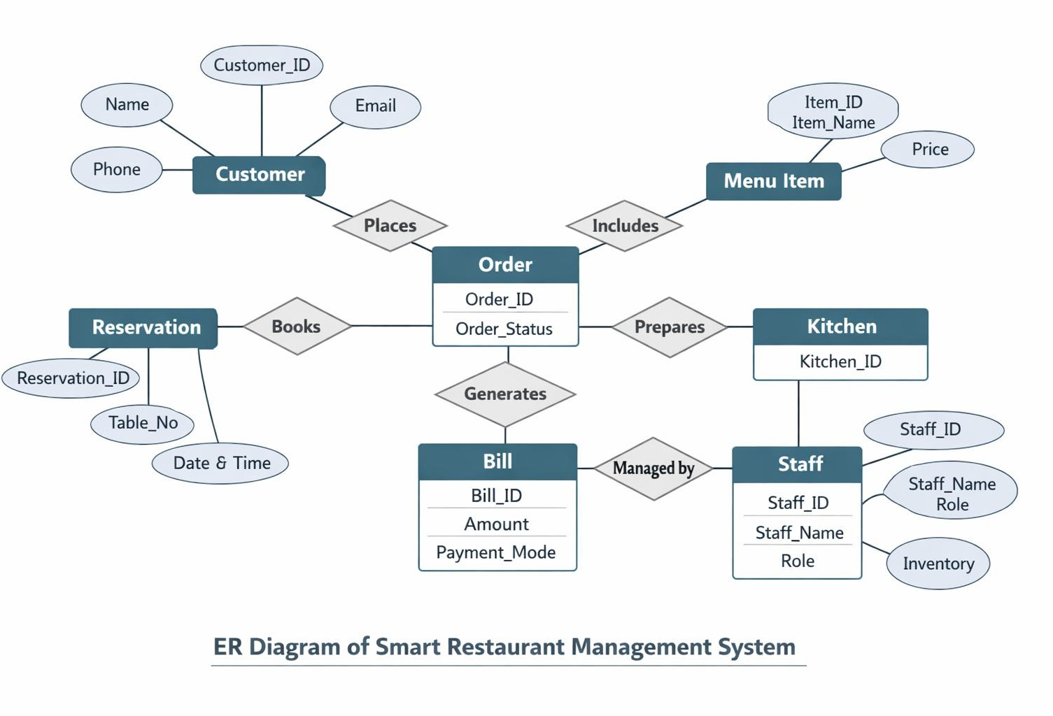
- ER Diagram:

- Use Cases Of DFD:

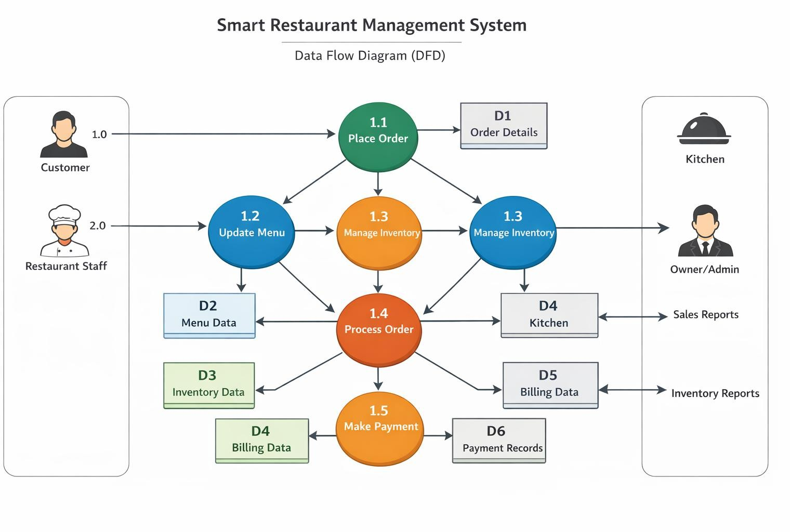
draw the data flow diagram of smart restaurant managemnt
Fig no 3.2 DFD For level 0

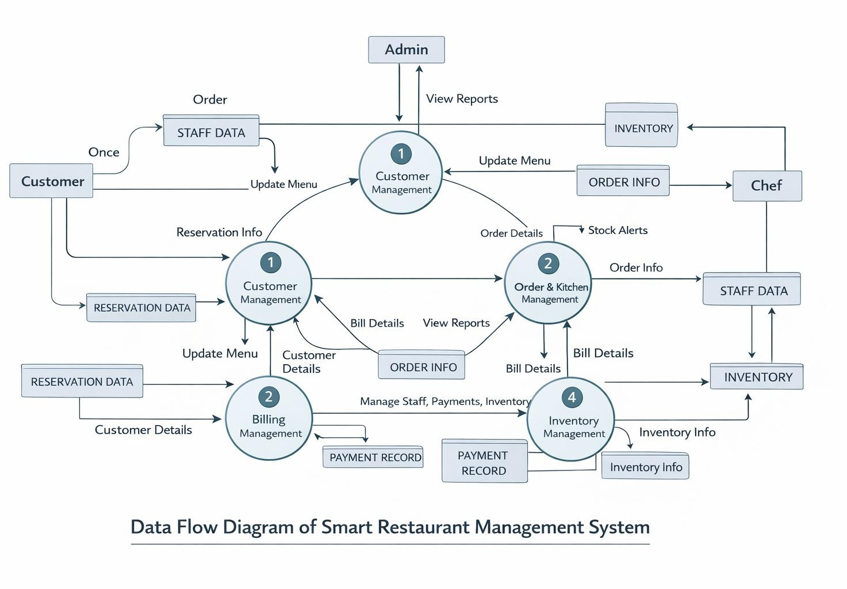
Fig no. 3.3 DFD For Level 1

CHAPTER 4 SYSTEM REQUIREMENT

SOFTWARE REQUIREMENT

Operating System:
The platform should be compatible with major operating systems such as Windows, macOS, and Linux so that users and administrators can access the system through web browsers.

Web Browser:
Modern web browsers such as Google Chrome, Mozilla Firefox, Microsoft Edge, or Safari are required to access the platform and interact with its features.

Development Environment:
Visual Studio Code (VS Code) is used as the development environment for writing and managing the project source code.

Programming Languages:
The platform is developed using standard web technologies including HTML, CSS, and JavaScript to design the user interface and implement the functionality of the system.

Backend Services:
Firebase is used to provide backend services such as authentication, database management, and real-time data synchronization.

Database Management System:
Cloud Firestore (Firebase Database) is used to store and manage platform data such as tournaments, teams, match results, and user profiles.

HARDWARE REQUIREMENT

Computer System:
A computer or laptop with at least Intel i3 processor or equivalent, 4GB RAM, and basic storage capacity is sufficient for development and testing.

Storage:
Adequate storage is required to store the project files, database records, and

related resources.

Internet Connection:
A stable internet connection is necessary to access the platform, retrieve tournament data, and communicate with the cloud database.

Server / Cloud Infrastructure:
Firebase cloud services are used to host and manage the database and authentication services of the platform.

User Devices:
Users can access the platform using devices such as desktop computers, laptops, tablets, or smartphones with an internet connection.

CHAPTER 5 EXPECTED OUTCOME
The Smart Restaurant Management System is expected to significantly improve the overall efficiency and performance of restaurant operations by automating manual tasks and providing a digital platform for management.

Improved Operational Efficiency
The system will streamline processes such as order management, billing, and inventory, reducing time and effort.

Faster Service
Orders will be processed quickly and sent directly to the kitchen, reducing waiting time for customers.

Reduced Errors
Automation will minimize human errors in order-taking, billing, and record-keeping.

Enhanced Customer Satisfaction
Customers will enjoy features like digital menu, online ordering, and quick service, leading to a better experience.

Better Data Management
All data related to customers, orders, and payments will be stored securely and can be accessed easily.

Real-Time Monitoring
Restaurant owners can track orders, sales, and inventory in real-time.

Cost Optimization
Reduction in manual work and better inventory control will help lower operational costs.

Increased Profitability
Efficient management and improved customer service will lead to higher revenue.

Scalability
The system can be expanded easily to include more features or multiple branches.

Decision-Making Support
Reports and analytics will help management make better business decisions.

CHAPTER 6 CONCLUSION AND FUTURE WORK

CONCLUSION -
The Smart Restaurant Management System provides an effective solution to automate and simplify restaurant operations. It replaces traditional manual methods with a digital system that improves efficiency, accuracy, and speed in managing daily activities such as order processing, billing, inventory control, and customer management.

The system enhances customer experience by offering faster service, easy ordering, and convenient payment options. At the same time, it helps restaurant owners and staff by reducing workload, minimizing errors, and providing real-time insights through reports and analytics.

Although there are some challenges like initial cost and technical complexity, the overall benefits of the system outweigh these limitations. With continuous advancements in technology, the system can be further improved by integrating features like artificial intelligence, online delivery services, and advanced analytics.

In conclusion, the Restaurant Management System plays a vital role in modernizing restaurant operations, increasing productivity, and ensuring better customer satisfaction, making it an essential tool for the growth and success of the restaurant business.

REFERENCES

  - W3Schools. “HTML Tutorial.” Available at: https://www.w3schools.com/html/

  - W3Schools. “CSS Tutorial.” Available at: https://www.w3schools.com/css/

